Cloudera installation steps

**RHEL-7.6_HVM-20190515-x86_64-0-Hourly2-GP2** - ami-015453d00db6f4699

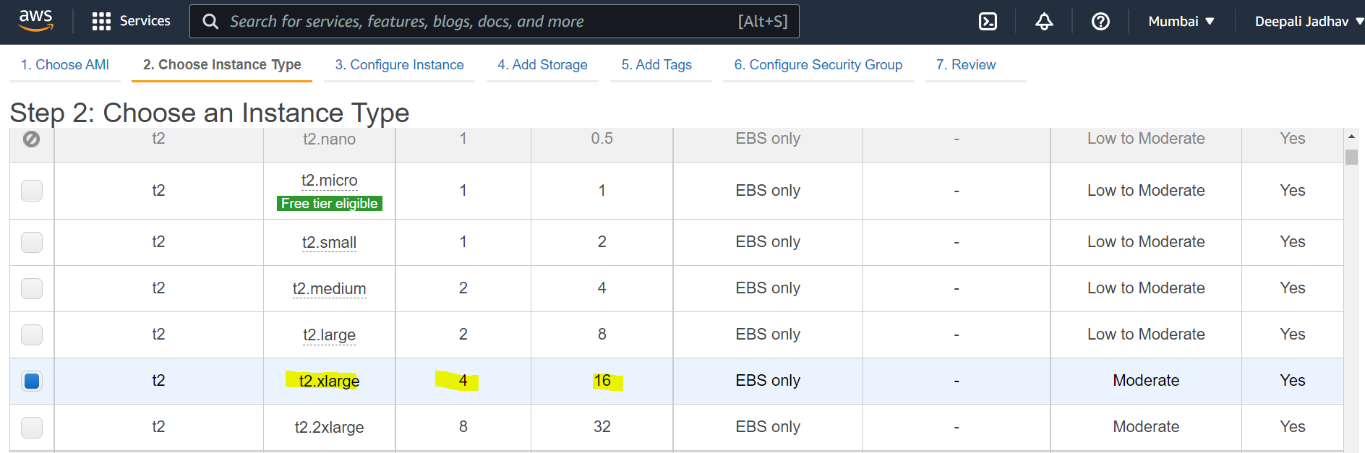

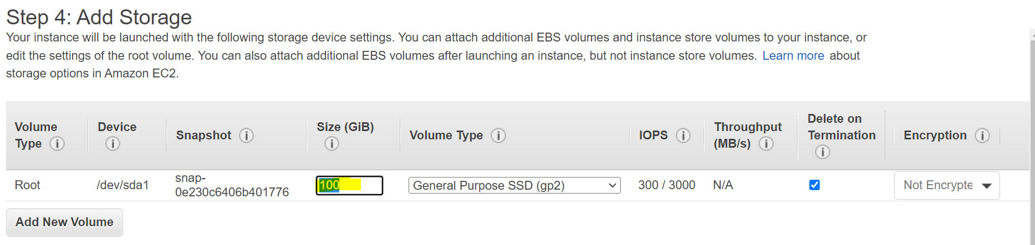

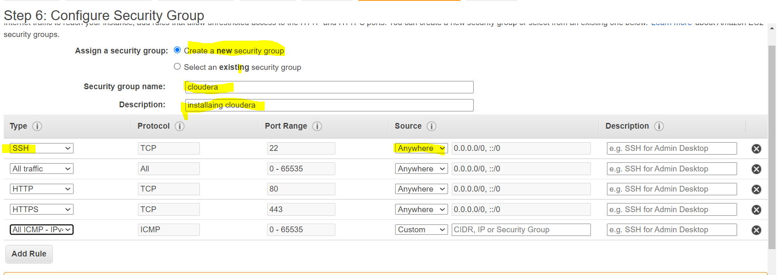

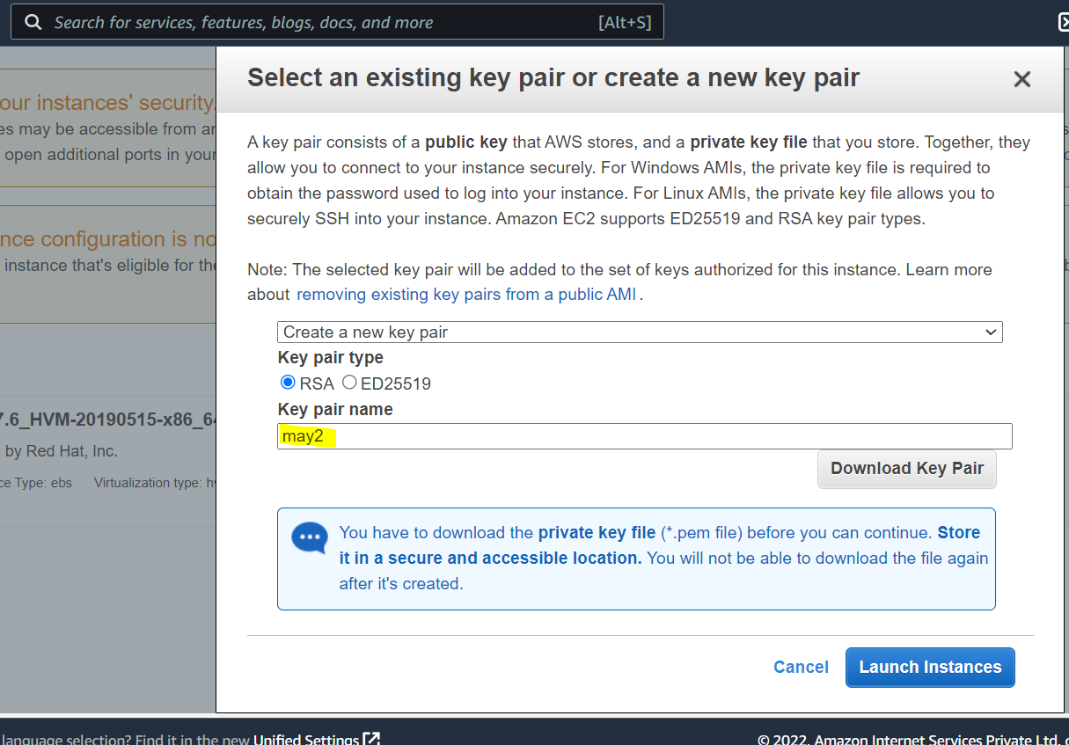

vi /etc/sysconfig/network

add

HOSTNAME=ip-172-31-6-49.ap-south-1.compute.internal

Install apache webserver: login as root

Yum install httpd -y

